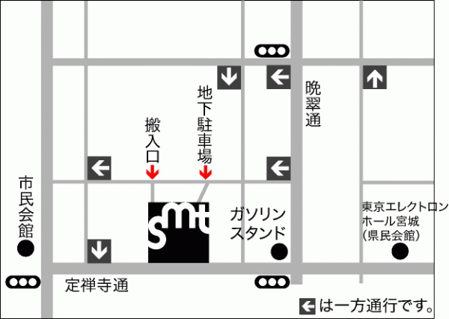

|  |  |  |
| --- | --- | --- |
| カタカナ | かんじ | Vocabulary |
|  |  |  |

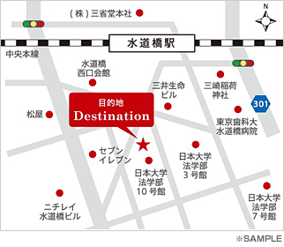

|  |  |  |
| --- | --- | --- |
| カタカナ | かんじ | Vocabulary |
|  |  |  |

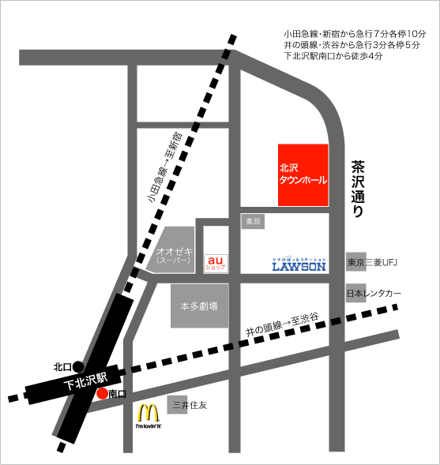

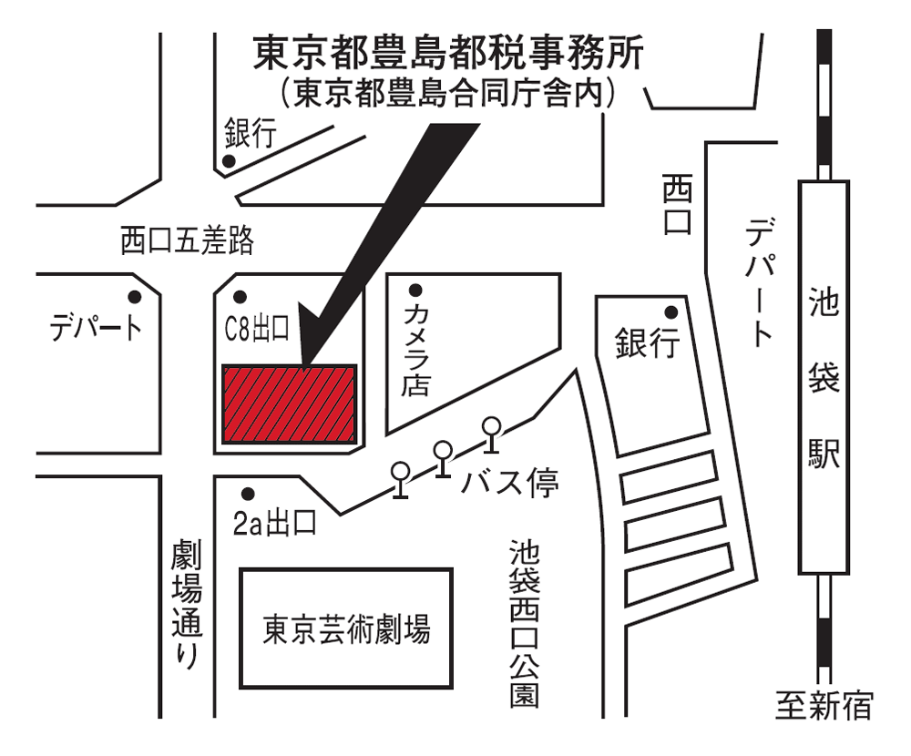

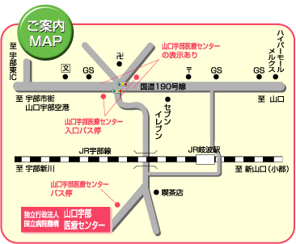

|  |  |  |
| --- | --- | --- |
| カタカナ | かんじ | Vocabulary |
|  |  |  |

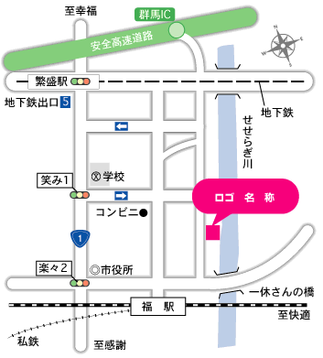

|  |  |  |
| --- | --- | --- |
| カタカナ | かんじ | Vocabulary |
|  |  |  |